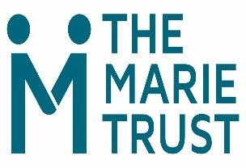**Trust Counselling Service Self - Referral Form**

**Submission of this form will be treated in the strictest of confidence**

**Name:**

**Date of birth:**

**Telephone no:**

**Address:**

**Some personal information about reasons for counselling.**

**Are you currently homeless? Yes** ○ **No** ○

(We regret that unfortunately we are currently unable to begin to offer a service to people who are in permanent accommodation)

**What best describes your accommodation status?**

Rough Sleeping ○B&B ○TFF ○Hostel ○Sofa surfing ○NFA ○other ○

Reason for Counselling (optional)

**Reason for Counselling (optional)**

**The service runs at several venue. Please indicate your preference**

* The Marie Trust
* Chara Centre (residents only)
* Over the Phone (during lockdown or in specific circumstances)
* Other preferred venue, this could be supported accommodation, NHS premises.

**You can access the service by:**

* **Speaking** with a member of staff; **or**
* **Phoning** or **Texting** David 07483165983 or Allyson 07907 842 929.
* **Completing the Form** on the page above and handing it in or emailing DCrossley@themarietrust.org.uk
* **Asking a Professional to Refer you** (the referral form can be sent via email or downloaded from our website)

**OFFICIAL - Sensitive**